Dear Parents and Carers,

We would like to take this opportunity to share information about our 2026 Student Resource Scheme (SRS), which was endorsed by our P&C Association. The SRS fee will be $90 per participating student, offering families excellent value and access to a range of high-quality online learning programs, The Resilience Project Journal, and art and craft supplies.

Below is an overview of the key programs included and the benefits they provide to our students:

Seesaw:
Seesaw for Schools is an innovative digital platform designed to engage students in learning and streamline communication between teachers, students, and parents. It provides a comprehensive set of tools that help educators manage their curriculum, assess progress, and provide personalised feedback.

Key Features:

1. Interactive Lessons: With Seesaw, teachers can create multimedia lessons and interactive activities to engage students in learning and helps personalise learning to cater to different learning styles.

2. Student Portfolios: Each student has their own digital portfolio where they can store assignments and evidence of their work. This allows teachers to track individual progress easily and offer personalised feedback

3P Learning:

The 3Essentials Package includes Reading, Writing, and Maths through platforms such as Mathletics, Mathseeds, Reading Eggs, Reading Eggspress, Fast Phonics, The Library, Mathseeds Prime, and Writing Legends, these are all accessible via a single login.
This integrated solution supports students to close learning gaps while providing extension opportunities for those ready to be challenged.

The Resilience Project:

Grounded in evidence-based principles of Gratitude, Empathy, Mindfulness (GEM), and Emotional Literacy, The Resilience Project helps students build lifelong wellbeing habits. The program also strengthens educator resilience and empowers families to support wellbeing at home.

Through engaging lessons and tailored resources, the program enriches our school community and promotes positive mental health for students and staff alike.

Here is a breakdown of the cost benefits for students and families that participate in our SRS scheme.

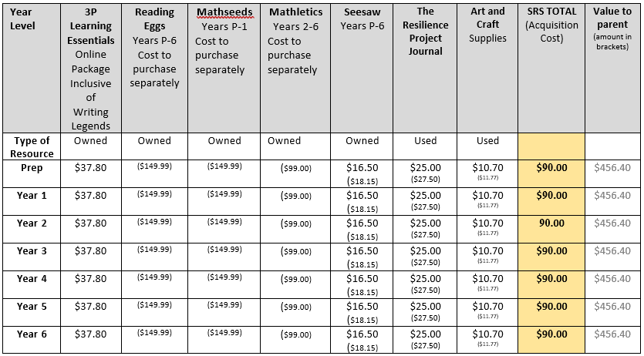

Consent for participation in our Student Resource Scheme (SRS) remains valid for the duration of your child’s enrolment at Norfolk Village State School. If at any time you decide not to participate, please contact us by emailing enrolments@norfolkvillagess.eq.edu.au

Kind Regards,

Norfolk Village State School

